Dolphin Magic School
Dakshinkali 9, Lamagaon

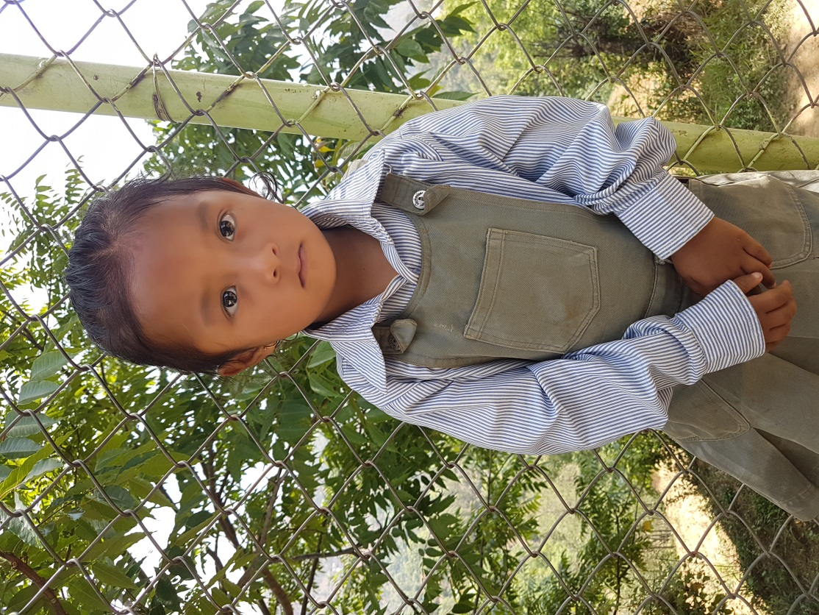
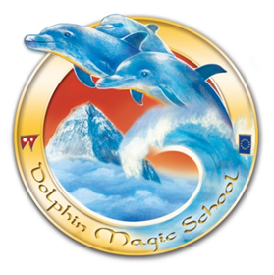
Student’s Information

Student’s Name: Shimar Balami
Date of birth: Friday, February 14, 2014
Father’s Name: Sunil Balami
Mother’s Name: Bina Balami Tamang
Grandfather: Tirtha bahadur Balami
Grandmother: Bijuli Kanchi Balami
Family members: 3
Permanent Address: Dakshinkali 9, Talku
Temporary Address:
Family Background,Occupation or any income source.
Economic Condition: Medium
Occupation: Farming
Background story:
Her father is Nepal Police. Her mother is house wife. Her father and mother got intercast marriage. Their family condition is medium.

