Dolphin Magic School
Dakshinkali 11, Lamagaon

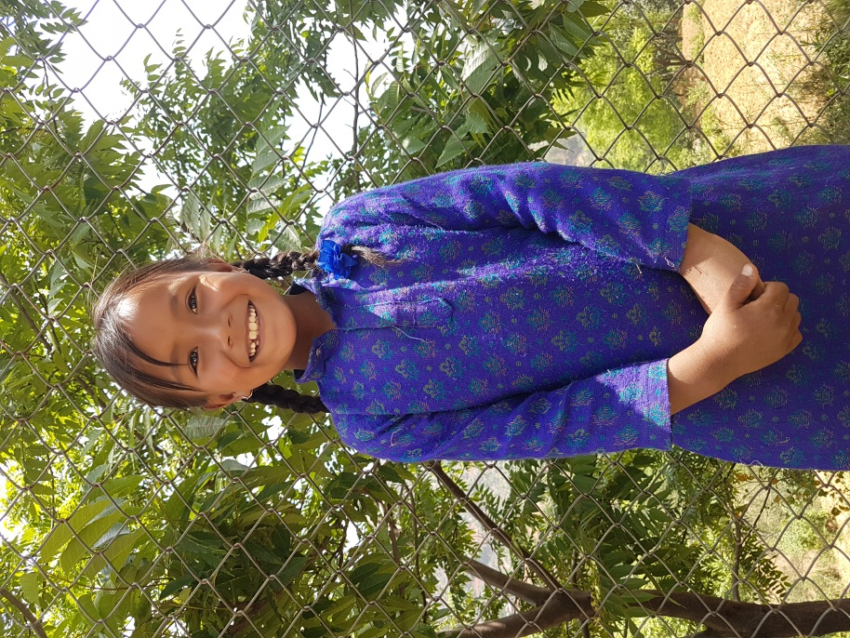
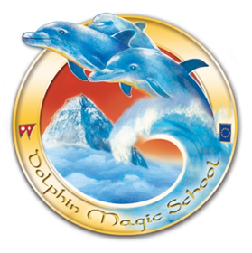
Student’s Information

Student’s Name: Ritu Thokar
Date of birth: Tuesday, March 3, 2009
Father’s Name: Tshring Thokar Lama
Mother’s Name: Jamuna Thokar
Grandmother: Saraswoti Thokar
Family members: 8
Permanent Address: Phakhel, Makawanpur
Temporary Address: Dakshinkal-11, Lamagaon
Family Background,Occupation or any income source.
Economic Condition: Weak
Occupation: Farming
Background story:
Her father is a driver. He works and live in Kathmandu. Her mother is a farmer. She has grandparents and two siblings. Being father is only working for money, their economic condition is not so good. Hence, she is staying in her sister’s house. Ritu is staying at her sister’s house as a care giver to child.

