Dolphin Magic School
Dakshinkali 9, Lamagaon

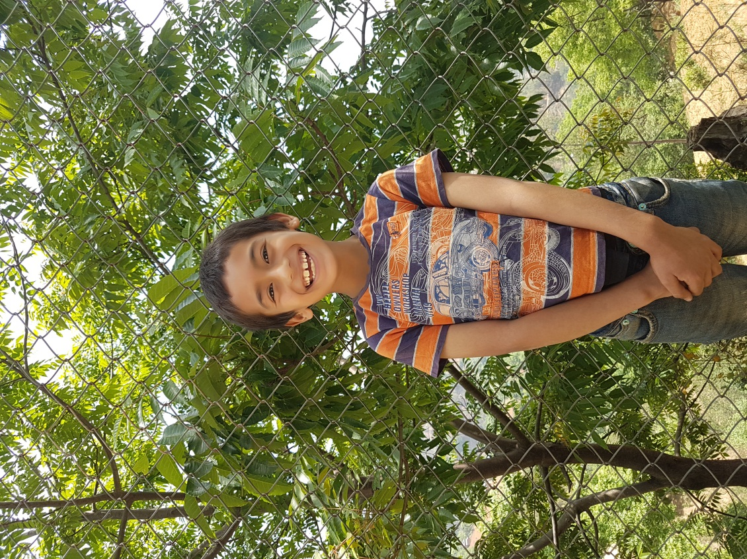
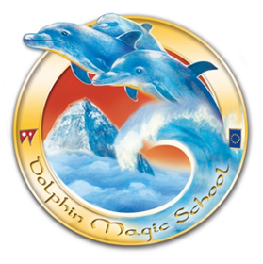
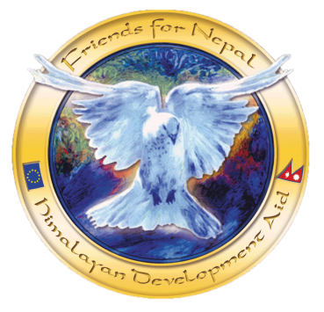
Student’s Information

Student’s Name: Kushal K.C (Khatri)
Date of birth: Thursday, September 24, 2009
Father’s Name: Kumar Khatri
Mother’s Name: Makhmali Khatri Bista
Grandfather: Govardhan Khatri
Grandmother: Durga Khatri
Family members: 4
Permanent Address: Dakshinkali 9, Talku
Temporary Address:
Family Background,Occupation or any income source.
Economic Condition: Weak
Occupation: Farming
Background story:
His father was employed in Dubai as Dubai police. Now his job is gone and he is staying at home and nothing to do. He along with his brother was studying in another private school but because they couldn’t afford to pay the fees and expenses they have come to Dolphin Magic School with all needed documents. His mother is working in Cooperative society as a collector and they are living with that income.

