Dolphin Magic School
Dakshinkali 9, Lamagaon

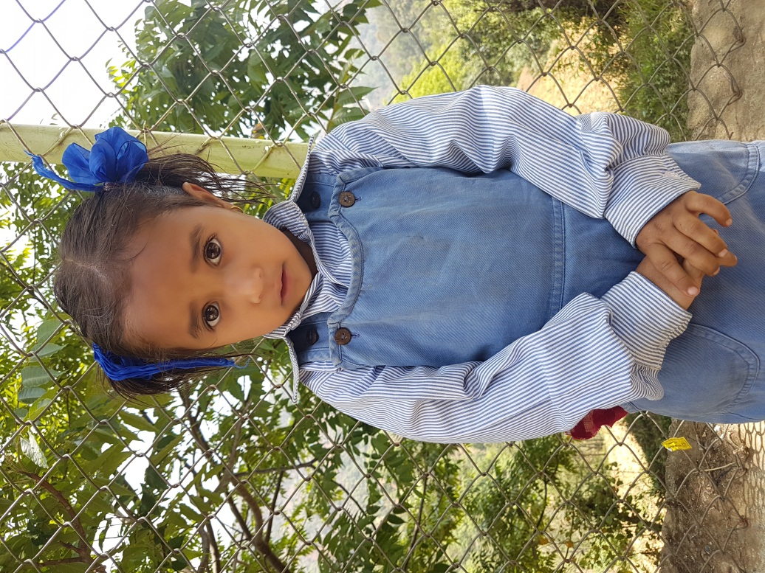
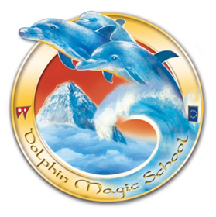
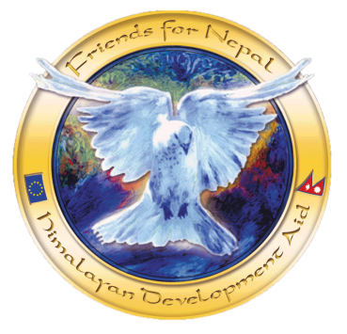
Student’s Information

Student’s Name: Cijal K.C
Date of birth: Wednesday, April 2, 2014
Father’s Name: Shekhar K.C
Mother’s Name: Narayani K.C Bista
Grandfather: Manhari K.C
Grandmother: Ishwori K.C
Family members: 7
Permanent Address: Dakshinkali 9, Talku
Temporary Address:
Family Background,Occupation or any income source.
Economic Condition: Medium
Occupation: Farming
Background story:
Her father is a Nepal Army. Her mother is a house wife. She has got one sibling. They have joint family. Her uncle is English teacher at Dolphin Magic School. Her family condition is medium.

